Oxford Nanopore Direct RNA Sequencing (RNA004)

1. Overview
This analysis examined a human Oxford Nanopore RNA004 direct RNA sequencing test dataset obtained from Zenodo record 15853348. Raw POD5 signals were basecalled with Dorado, assessed with NanoPlot, aligned to the GENCODE v46 transcriptome using minimap2, and visualized as signal to reference alignments using Squigualiser Option 2 (basecaller move table).

2. Basecalling
The POD5 data were basecalled using Dorado 0.5.3 and the RNA004 specific super accuracy model rna004_130bps_sup@v3.0.1 on an NVIDIA H100 GPU. The command used --device cuda:0, --emit-moves, and --min-qscore 0.
The RNA004 model matches the pore chemistry and 130 bases per second RNA sequencing mode. The SUP configuration prioritizes basecalling accuracy. Emitting moves preserves the move table information required for Squigualiser Option 2, while a minimum Q score of zero avoids excluding low quality reads before quality assessment.
The output BAM contained 10,074 basecalled reads and retained move tags.

3. Read Quality Assessment
NanoPlot 1.48.0 processed the unaligned Dorado BAM using the parameters --ubam, --threads 4, and --plots hex dot. The interactive NanoPlot HTML report is included as a separate submission file.
Metric | Observed value
Basecalled reads | 10,074
Total bases | 10,745,746 (10.75 Mb)
Mean / median read length | 1,066.7 / 793 nt
Read length N50 | 1,482 nt
Read-length standard deviation | 890.3 nt
Mean / median read quality | Q12.2 / Q14.1
Reads above Q10 | 9,325 (92.6%)
Reads above Q15 | 2,724 (27.0%)
Reads above Q20 | 36 (0.4%)
Longest read | 18,311 nt (Q2.0)
Interpretation: The 10.75-Mb yield and N50 of 1,482 nt indicate a heterogeneous collection of RNA reads, with many shorter molecules and a smaller number of longer reads. Most reads exceed Q10 (92.6%), whereas only 27.0% exceed Q15 and 0.4% exceed Q20, indicating variable basecall confidence. The longest read (18,311 nt) had Q2.0, illustrating that read length alone does not establish read reliability. RNA degradation, variable transcript lengths, and sequencing/basecalling effects could contribute to the distribution, but the summary statistics alone cannot distinguish these causes.

4. Transcriptome Alignment
The human GENCODE v46 transcript FASTA was downloaded, and its headers were simplified to transcript accessions. minimap2 version 2.31-r1302 aligned the FASTQ reads using -ax map-ont -t 8, followed by sorting, indexing, and alignment statistics using samtools version 1.24.
The map-ont preset is designed for Oxford Nanopore long reads, which typically have higher sequencing error rates than short reads. A transcriptome reference is appropriate for mapping mature RNA molecules without requiring genomic splice aware alignment.
The samtools flagstat results reported 10,074 primary alignment records, 22,589 secondary alignment records, 570 supplementary alignment records, and 9,471 mapped primary records. Therefore, 9,471 out of 10,074 basecalled reads were successfully mapped, corresponding to a primary read mapping rate of 94.01%. The remaining 603 reads were unmapped.
The overall mapped alignment percentage was 98.19%. However, this percentage includes secondary and supplementary alignment records and does not represent the percentage of individual reads successfully mapped. Therefore, 94.01% was used as the primary read mapping percentage.
Interpretation: The 94.01% mapping rate indicates that most of the basecalled reads aligned successfully to the human transcriptome reference. The presence of multiple secondary alignments may result from similarities between transcript sequences or homologous regions. However, a high mapping percentage does not necessarily indicate that all reads were uniquely assigned or represent complete RNA transcripts.

5. Raw Signal Visualization Using Squigualiser
Squigualiser version 0.7.0 was used with Option 2, which utilizes Dorado move table information to connect electrical signal measurements with basecalled nucleotide positions and their corresponding reference transcript locations.
The original POD5 file was converted into BLOW5 format using Blue Crab. Six base called reads containing fewer than nine nucleotides were excluded before signal reforming. Squigualiser reform was performed using the parameters --rna -k 9 -m 0. The realign step then combined the signal alignment PAF file with the transcriptome alignment BAM file, producing 9,324 signal to reference alignment records.
The resulting PAF file was sorted, compressed using BGZIP, and indexed using Tabix. The complete visualization run used --rna, --sig_ref, --profile kmer_model_rna004_130bps_9mer, --loose_bound, and --auto, without a plot limit.
For transcript ENST00000387347.2 (MT-RNR2), which is 1,559 nucleotides long, 110 signal alignment records overlapped the requested region from positions 1360 to 1400 after accounting for the reversed coordinate ordering associated with RNA signal visualization.
A total of 110 interactive HTML plots were successfully generated for reads overlapping the target interval. The selected representative read, 0e014703-7f84-4b04-9757-7fdc1ae0cf1f, displays the reference interval from positions 1400 to 1360 in RNA orientation.
The visualization contains a blue electrical current trace, red points representing individual signal measurements, and colored regions corresponding to reference nucleotide positions. In the visible portion of the plot, the electrical current varies approximately between 55 and 120 picoamperes (pA), showing transitions between different current levels.
Interpretation: As RNA molecules pass through the nanopore, changes in the surrounding nucleotide sequence influence the ionic current measured by the sequencing device. Dorado interprets these electrical current patterns to predict the nucleotide sequence. The move table provides an approximate relationship between signal measurements and successive base called nucleotides, while transcriptome alignment determines their corresponding positions on the reference transcript.
The colored nucleotide regions in the Squigualiser visualization illustrate how the electrical signal is associated with the reference sequence. Differences in current levels reflect changes in the local nucleotide environment. However, these variations alone do not provide direct evidence of RNA modifications.
Technical Limitations: The move offset parameter -m 0 used during signal reforming was not independently calibrated for the RNA004 model. The plotting profile applied a base shift of negative five. Additionally, Tabix produced warnings regarding coordinates less than or equal to zero during indexing, although the HTML plots were successfully generated.
Therefore, the visualization demonstrates the relationship between nanopore electrical signals and reference nucleotide positions, but the exact nucleotide level signal positioning has not been independently validated. The results should not be interpreted as definitive evidence of RNA modifications.
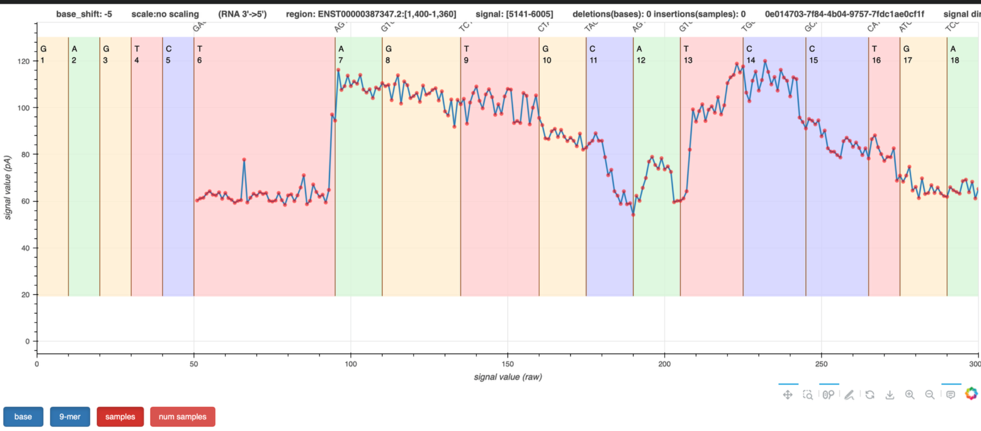
Figure 1. Screenshot of the Squigualiser interactive signal-to-reference visualization for ENST00000387347.2, positions 1360–1400 (shown 1400–1360 in RNA orientation).

6. Precision medicine application
Long-read RNA sequencing can help characterize disease-associated transcript isoforms, including exon combinations, retained introns, and alternative transcript ends. In cancer, for example, a long read can connect multiple splice events within the same RNA molecule, whereas short-read RNA-seq may struggle to reconstruct full-length isoforms unambiguously from short fragments. Identifying tumor-associated isoforms could improve biomarker discovery, reveal altered pathways, and support selection or monitoring of targeted treatments. Direct RNA sequencing can additionally preserve native RNA signals for future investigation of RNA modifications, provided that appropriate calibration and validation are performed.

7. Conclusion
The RNA004 dataset yielded 10,074 basecalled reads, a read-length N50 of 1,482 nt, and a 94.01% primary-read mapping rate to GENCODE v46 transcripts. NanoPlot revealed variation in read lengths and basecalling quality, while Squigualiser successfully generated 110 interactive raw-signal plots for the specified MT-RNR2 interval. This workflow demonstrated how direct RNA sequencing data can be processed from raw electrical signals to reference-aligned visualizations. However, precise signal-to-base positioning requires further validation of the move offset parameter. Overall, the analysis highlighted the importance of appropriate basecalling models, quality control, and alignment methods for reliable transcript characterization and potential precision medicine applications.

References and submitted files
- Zenodo dataset: https://zenodo.org/records/15853348
- Dorado: https://github.com/nanoporetech/dorado
- Squigualiser Option 2: https://github.com/hiruna72/squigualiser#option-2---basecaller-move-table-1
- GENCODE v46: https://ftp.ebi.ac.uk/pub/databases/gencode/Gencode_human/release_46/
- Accompanying files: README.md, NanoPlot HTML, and representative Squigualiser HTML; all 110 Squigualiser plots are available in signal_plots/all_target_reads on Quartz.

Generative AI was used as a writing and review assistant during this assignment. It was used to help organize and edit the wording of the written report and the README, to check my submission against the assignment requirements, and to suggest clarifications on technical wording. All sequencing analyses were run by me on the IU Quartz cluster, including Dorado basecalling, NanoPlot, minimap2 alignment, and Squigualiser visualization. All numerical results, figures, and output files come from those runs. I reviewed, verified, and take responsibility for the content of everything submitted, including the interpretations and the stated limitations of the analysis.

